### **Freedom Tunnel**

Database class project 2021/2022

|  |  |  |  |  |
| --- | --- | --- | --- | --- |
| Student Name in English | Student Name in Arabic | Student ID | Section | Work percentage |
| Sojod Majdy Majed Jamous | سجود مجدي ماجد جاموس | 11924705 | Sunday and Wednesday from 11:00-12:30 | 50% |
| Masa Abd Alnasser Issa | ماسه عبد الناصر سعيد عيسى | 11923603 | Monday and Thursday from 11:00-12:30 | 50% |

Date/time

---------------------------------------------This section is intended for the Instructor---------------------------------------

|  |  |
| --- | --- |
| **Topic** | **Mark** |
| Project Requirements and Modeling |  |
| Correctness of Database mapping |  |
| Functional Dependency and Normalization |  |
| Project Tools |  |
| Project Discussion |  |
| Project Completeness |  |
| Project Output Results or reporting (JasperReport, charts, graphs, etc.) |  |
| Project Administration and Management |  |
| Project Report |  |
| Project Idea |  |
| Project Complexity |  |
| Team work |  |
|  |  |
|  |  |
|  |  |

**Abstract:The Freedom Tunnel is a project that seeks to assist the families of the prisoners in the process of registering for visits, in addition to assisting the staff of the International Committee of the Red Cross in the process of coordinating the visits of prisoners**

**Content:**

**Introduction……………………………………….3**

**Project Requirement …………………………….4**

**Functional Dependency………………………….5**

**Project UML……………………..……………….7**

**Tables in 3NF…………………………..…............8**

**Tools Used…………………………………...........9**

**GUI Discussion…………………………………..10**

**SQL Statement ……………………..…….……..28**

**Jasper Report………………………………..…..29**

**Conclusion……………………..…………………30**

**References…………………………………….…..30**

**Introduction:**

From the motive of our love for the homeland Palestine, we chose a project related to our prisoners in occupation prisons, On the one hand, the project assists the families of the prisoners in registering and applying to visit their relatives in the occupational prisons, and on the other hand, the staff of the Red Cross helps in arranging the process of registering the families to visit and apply for permits to the occupation authority.

### **Data Requirements:**

The Red Cross Foundation provides assistance to prisoners and their families regarding the issue of visits by prisoners' families to their children imprisoned by the occupation

In the beginning, there are employees who help the families of the prisoners in registering to visit their children and inform them of their latest news. For each employee there is a (name, A unique identification number , Gmail , Password, date of birth ,address, phone number and gender)

Each employee has several visitors, who are the families of the prisoners, for each visitor there (a name, a unique identification number, date of birth, address, phone number, visitID, password).

Each visitor can have more than one prisoner, and each prisoner can have more than one visitor, up to a maximum of 3 visitors, for each prisoner there is (a name, unique identity number, date of birth, Number of years in prison , gender, prison Name and prison date )

For each prisoner there is a visit once a month. The visit contains (visitID , prison Name ,Registration Date ,date of the visit: date, employee SSN ,Address VisiterNum )

Each visitor, if he has more than one prisoner, is allowed to visit more than once a month, and one employee receives arrangements for more than one visit.

**UMl:**

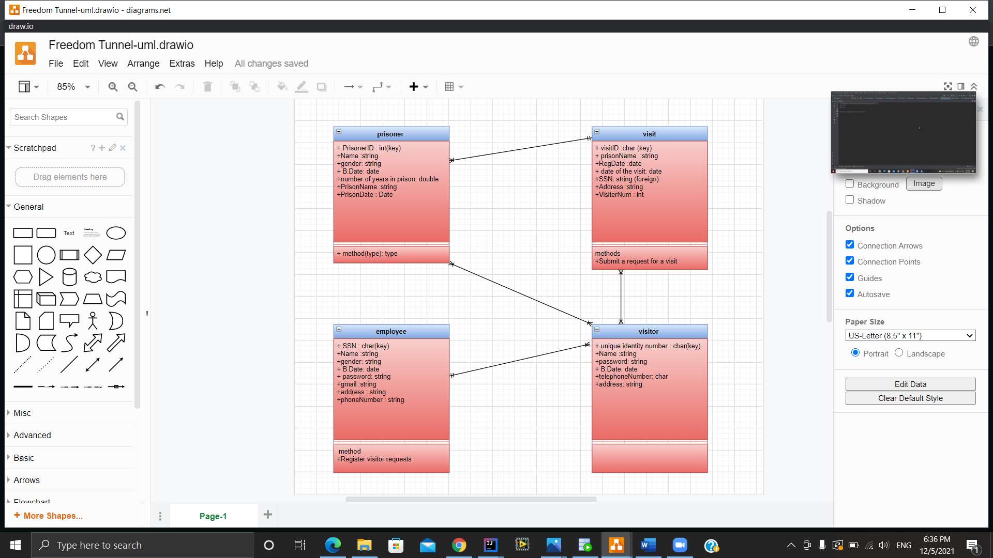

**Tools Used:**

1. Intellij as an IDE for Java.

2. Oracle slim as a database which is created inside

a docker container using docker-compose uml file.

3. Draw.io for creating the initial Database UML.

4. Scene Builder for creating the FXML files used inside the

JavaFX Project.

5. SQL Developer for connecting and creating the database

tables and SQL Testing.

6. CSS for styling the interfaces in JavaFX

7.Word documents.

**GUI:**

Main page:

This is the interface , the user can chose to log in as admin or visitor.

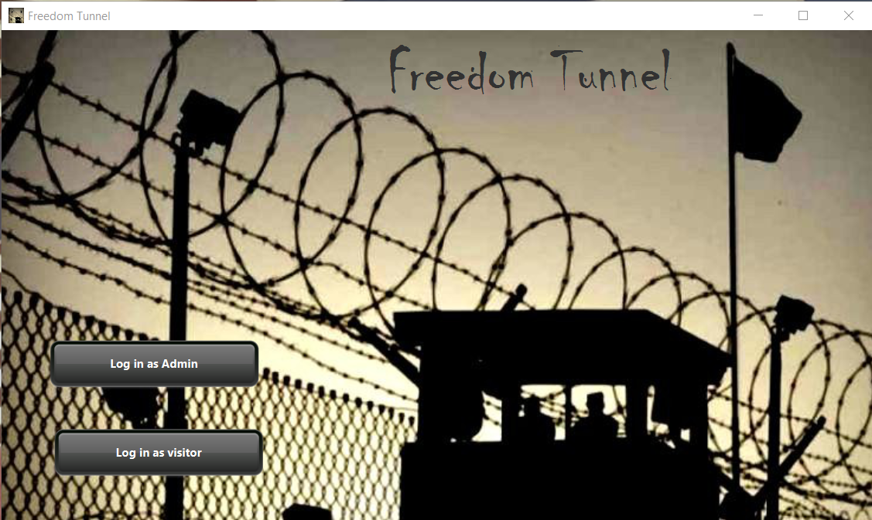

This page to log in as admin , from the email we can check if it’s an admin or not. 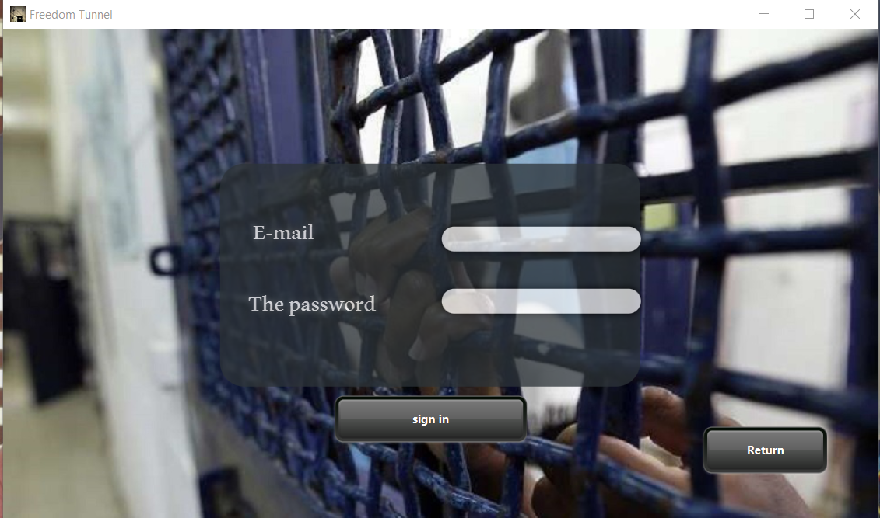

This page for the visitor log in to the system , the user can log in if the serial number existing in the data base .

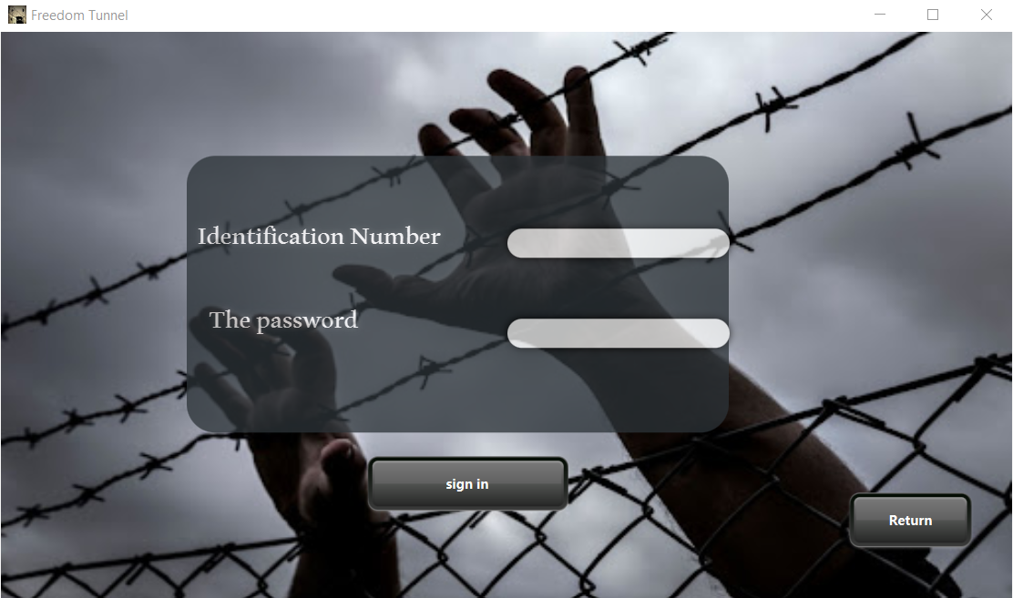

This page will appear when the administrator enters the system From the buttons, he can choose the screen he wants to go to. 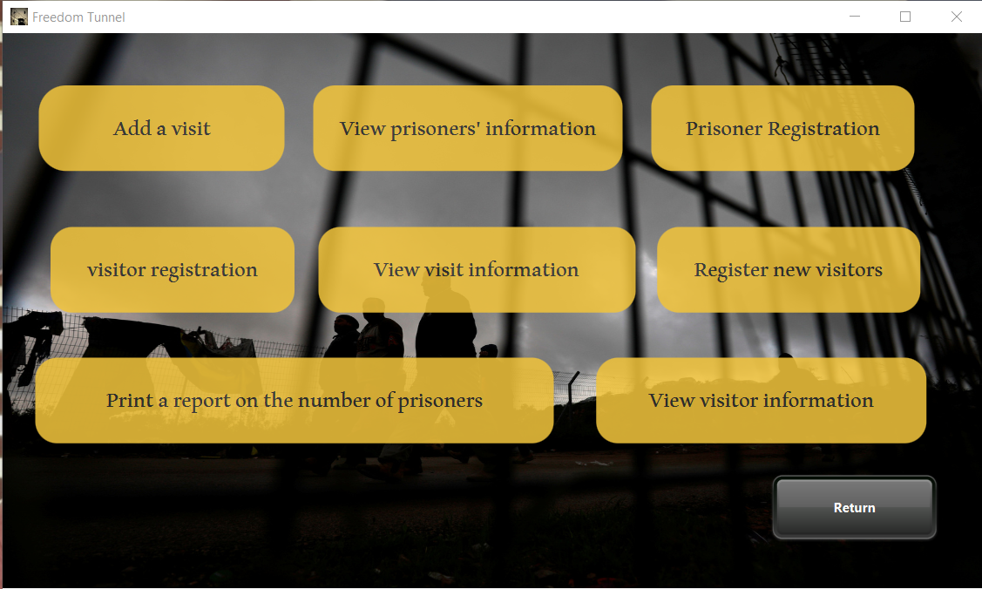

When the admin click on “Prisoner Registration” this page will appear to fill the information for a new prisoner.

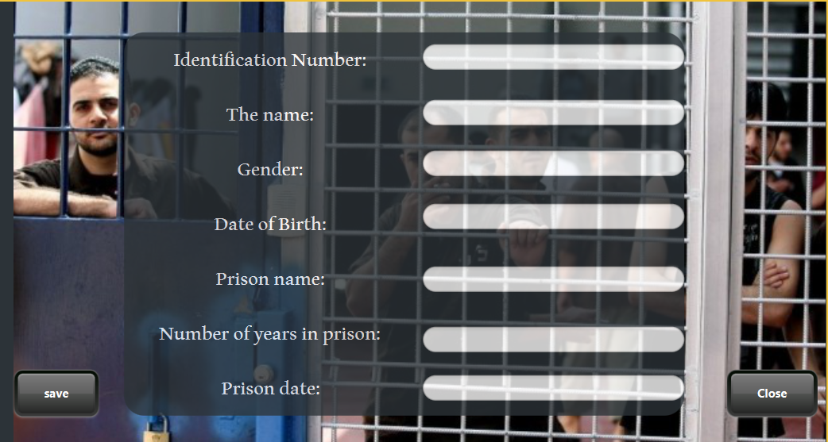

When the admin click on “View prisoner information” this page will appear to show the prisoner's previously registered information.

The admin can edit, delete and add, as well as print the information through the buttons below, and he can search for a specific visitor by entering the visitos number to be searched for in the text box and then pressing the search button

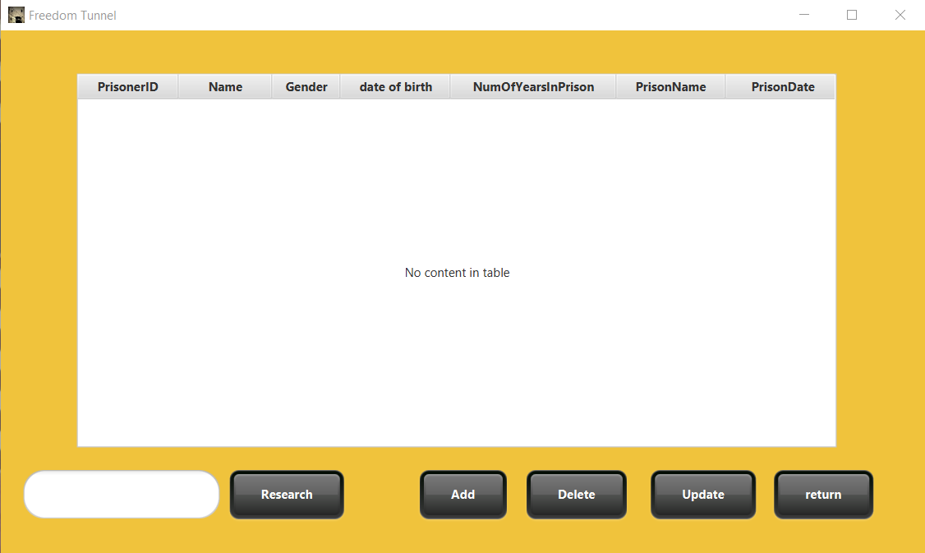

When the admin click on “View visit information” this page will appear to show the visit previously registered information.

The admin can edit, delete and add, as well as print the information through the buttons below, and he can search for a specific visit by entering the visit number to be searched for in the text box and then pressing the search button

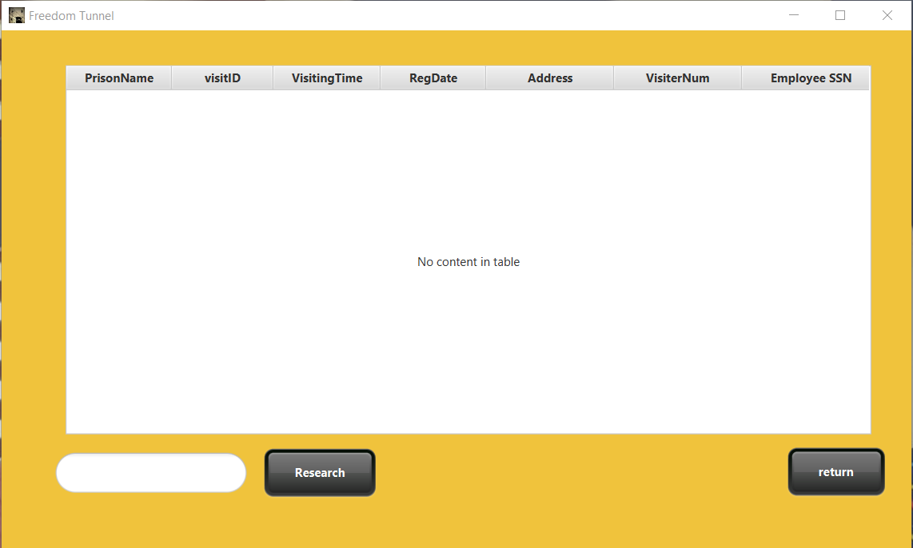

When the admin click on” add visit ”this page will appear to fill the information for a new visit

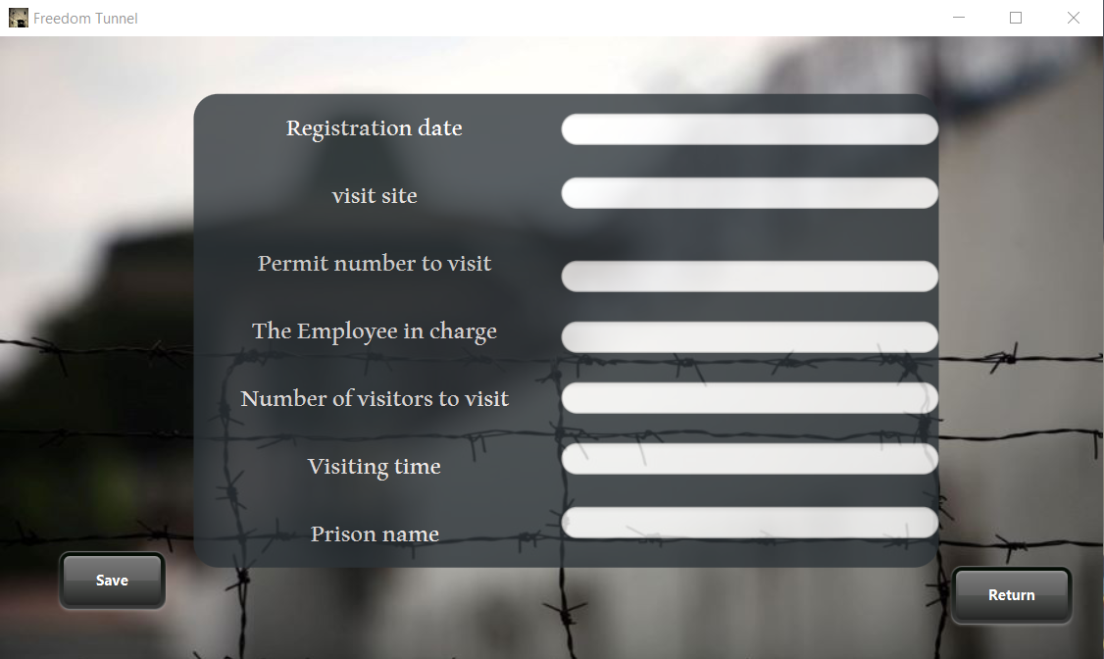

When the admin click on “Registration new visitor” this page will appear to fill the information for a new visitor.

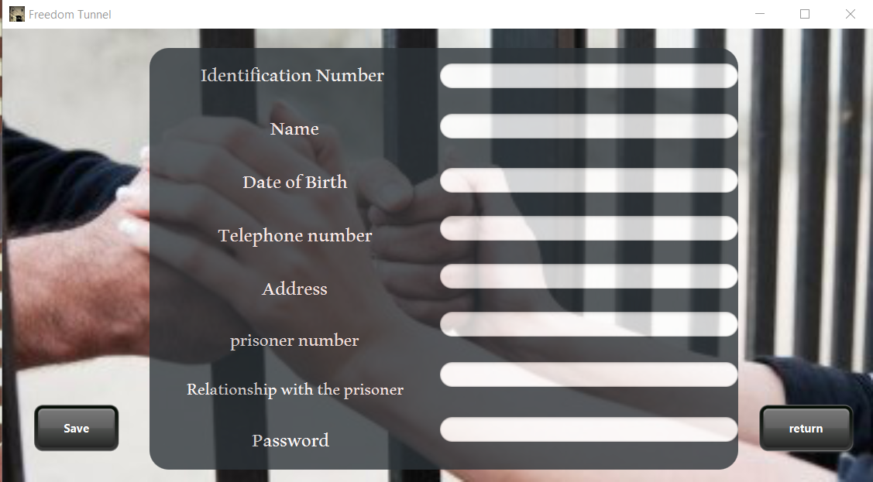

When the admin click on “View visitors information” this page will appear to show the visitors previously registered information.

The admin can edit, delete and add, as well as print the information through the buttons below, and he can search for a specific prisoner by entering the prisoner’s number to be searched for in the text box and then pressing the search button

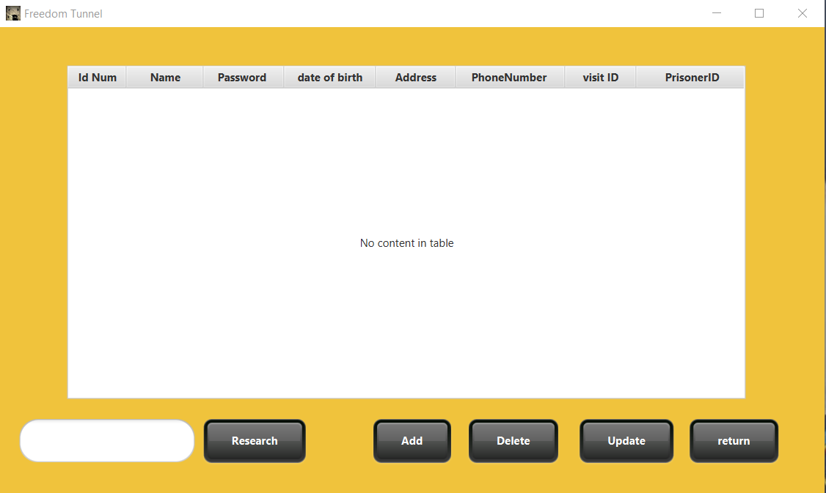

When the admin click on “visitors Registration” this page will appear to fill the information for a new visitors.

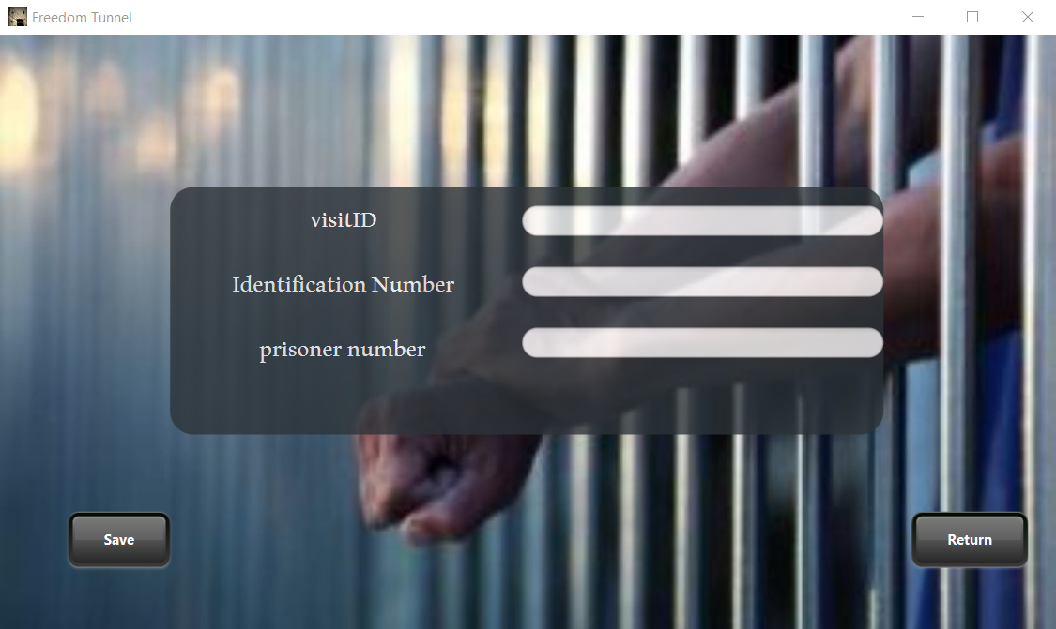

This page will appear when the visitor enters the system From the buttons, he can choose the screen he wants to go to.

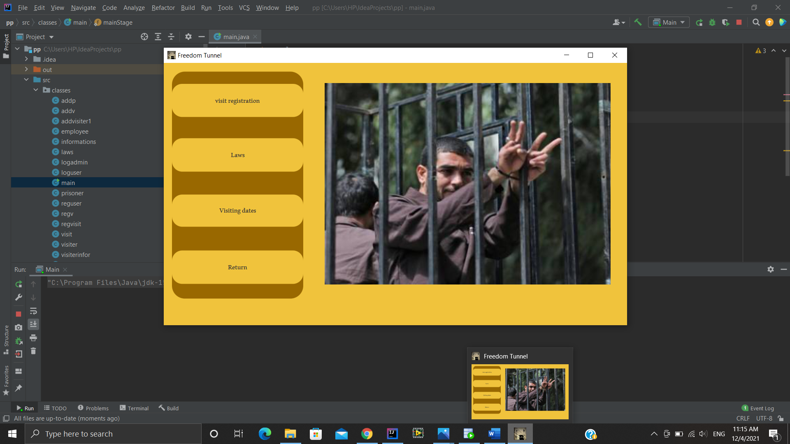

When the visitor click on “visit Registration” this page will appear to fill the information for a visit.



When the visitor click on “Law” this page will appear to show Visiting rules that show what is allowed and what is prohibited

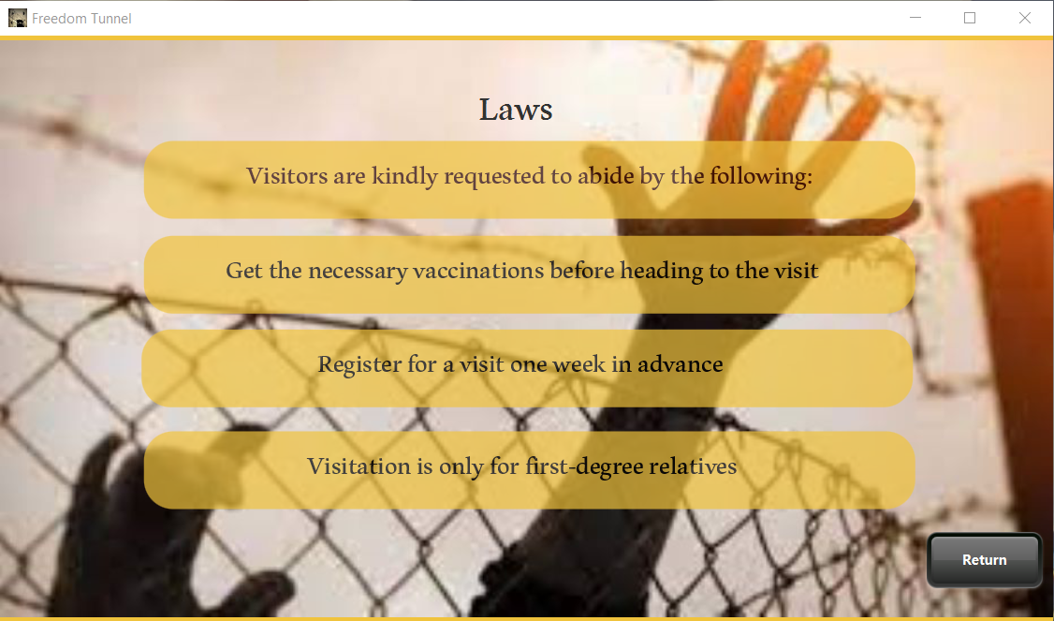

When the visitor click on “visiting Dates” this page will appear to show the information for the visit.

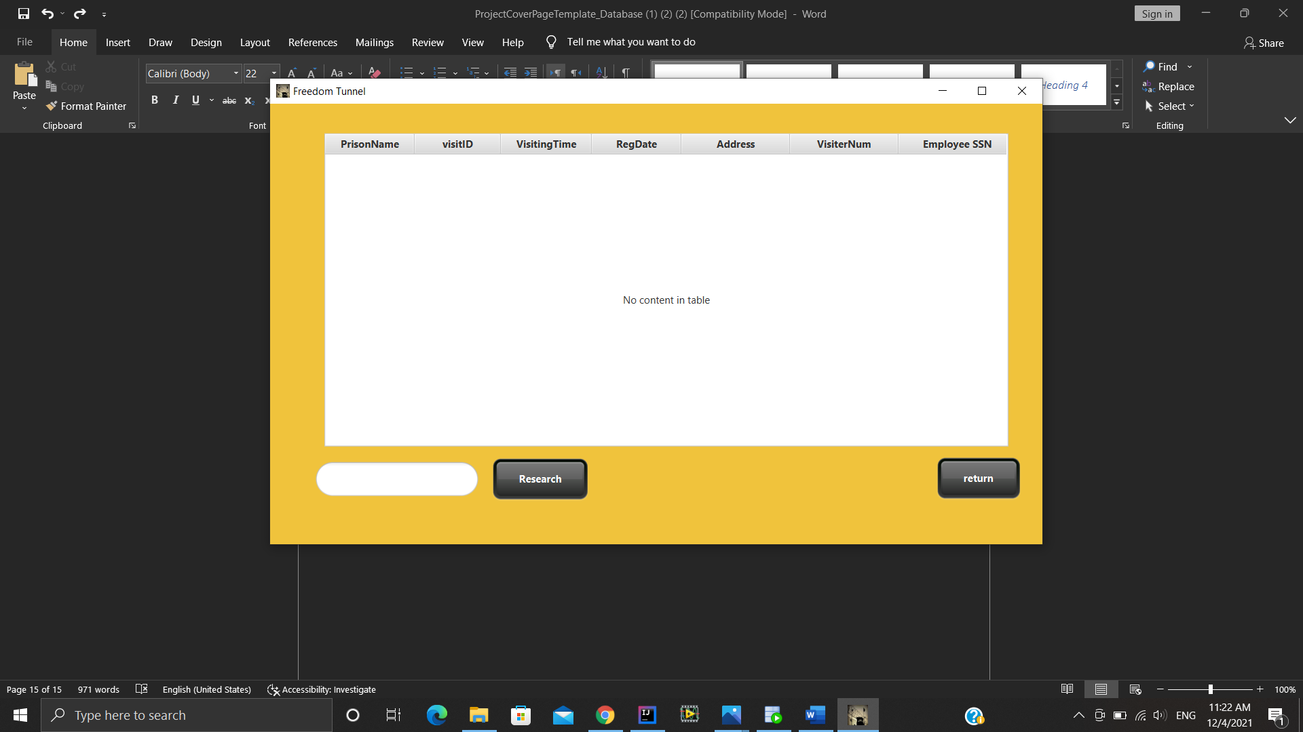

Sql:

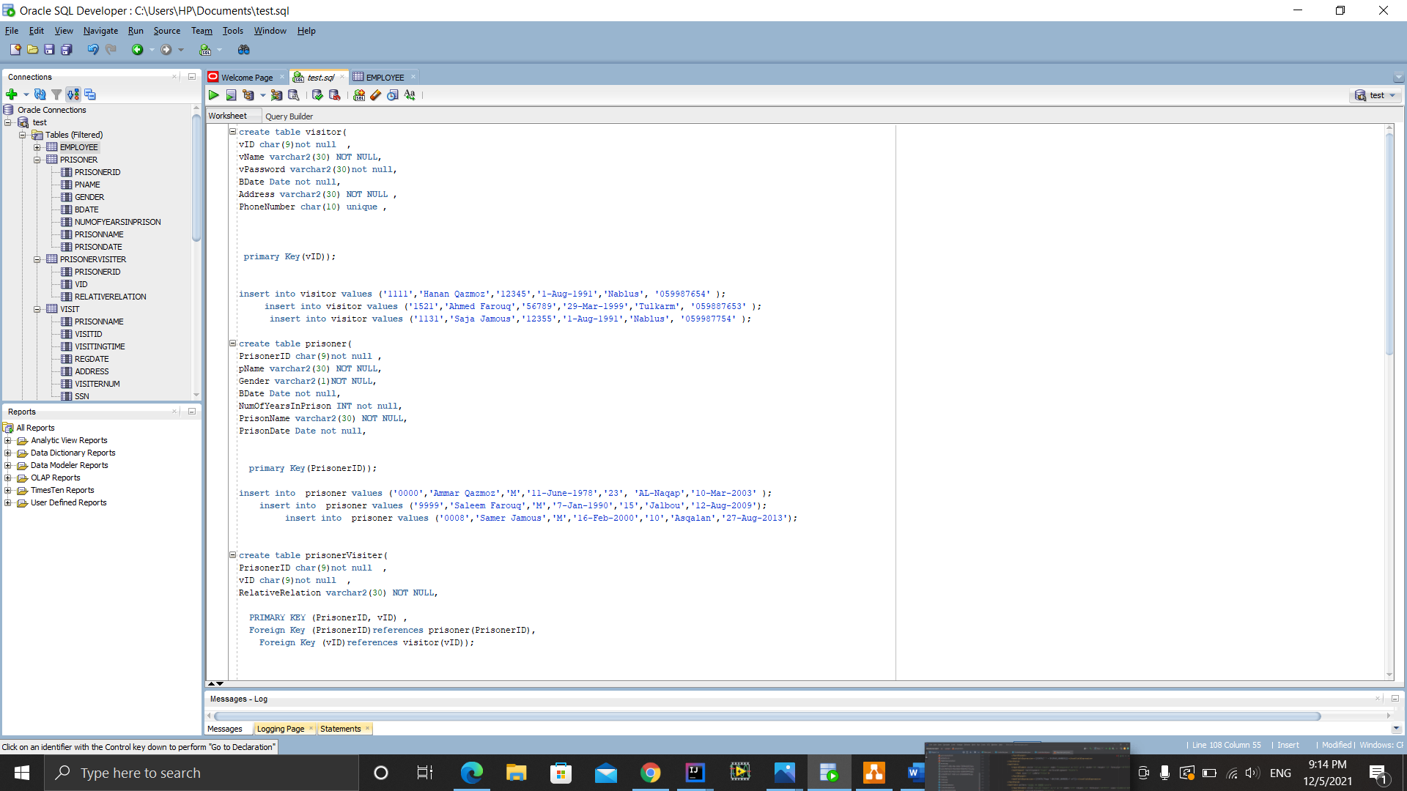

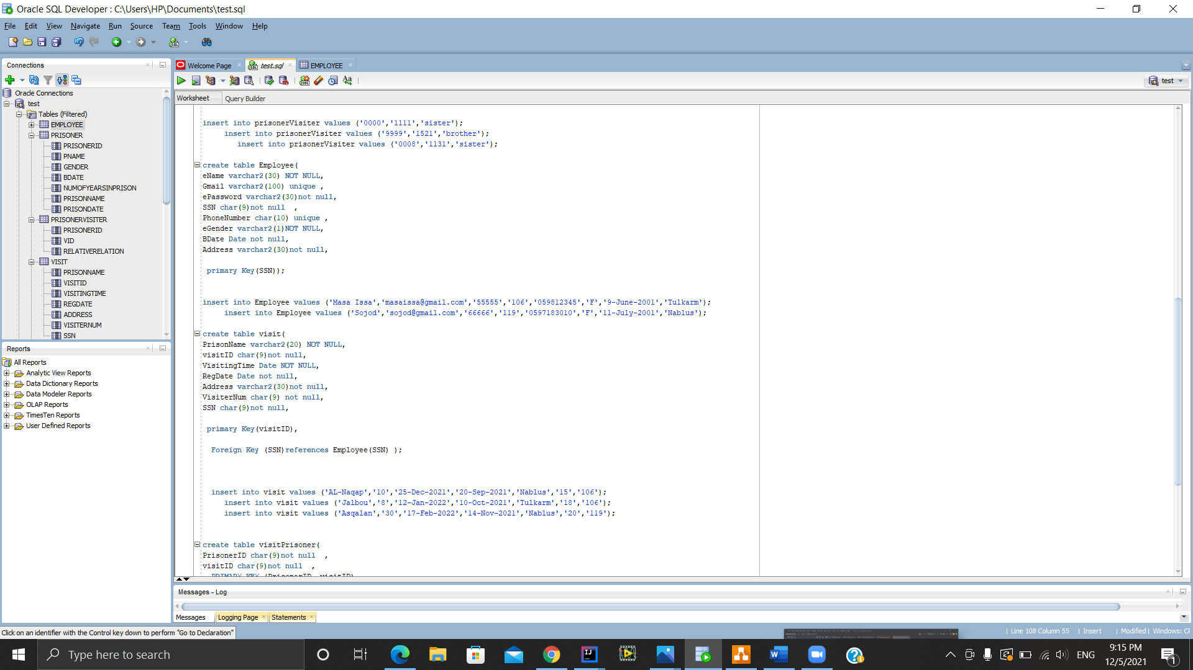

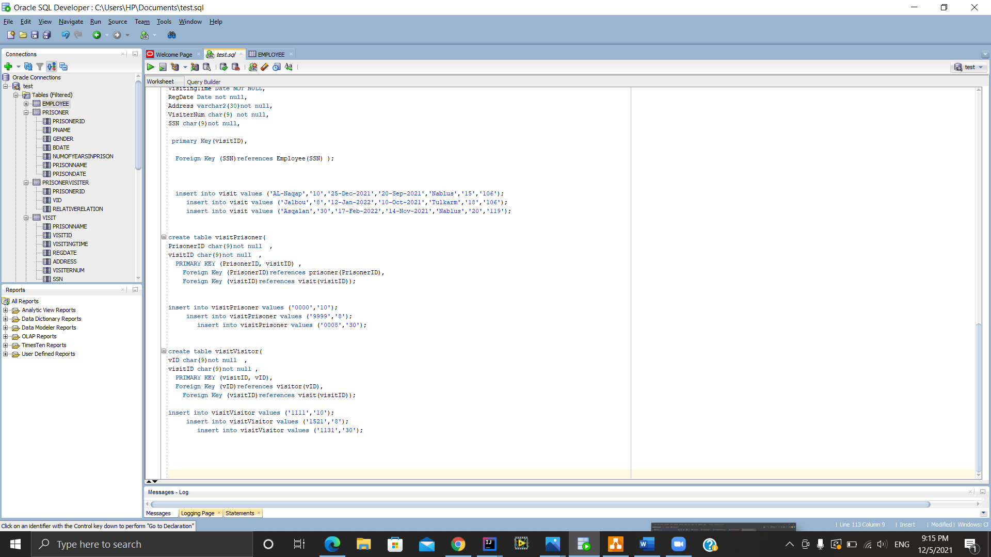

Functional Dependency:

Visitor table:

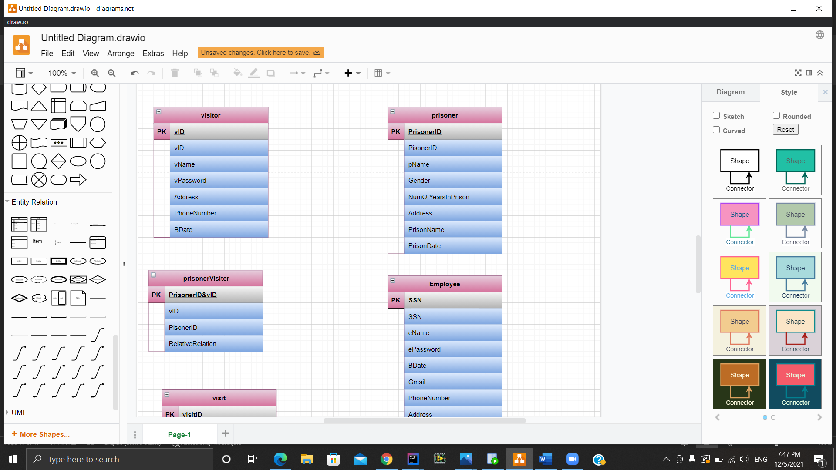

vID VisitID, vName,vPassword,Address,PhoneNumber,BDate

prisoner table:



PrisonerID pName, Gender, NumOfYearsInPrison, Address,PrisonName, PrisonDate.

Employee:

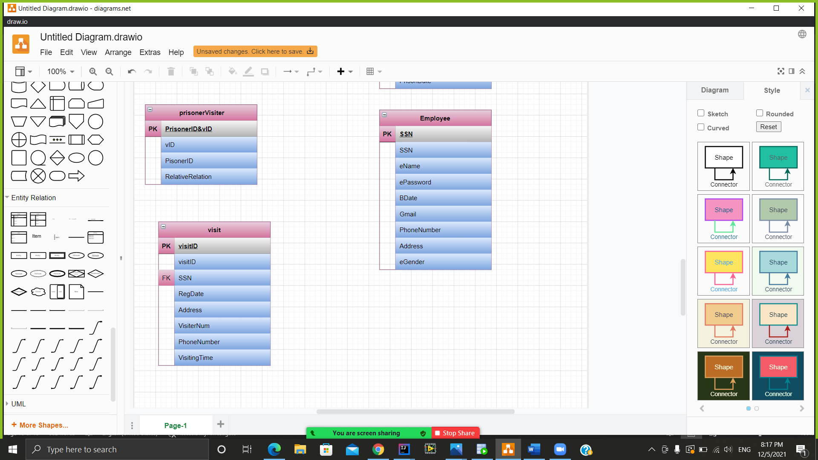

SSN eName, ePassword,BDate,Gmail,PhoneNumber,Address,eGender.

Visit:



visitID SSN(foreign key), RegDate, Address, VisiterNum, PhoneNumber, VisitingTime .

prisoner Visitor:

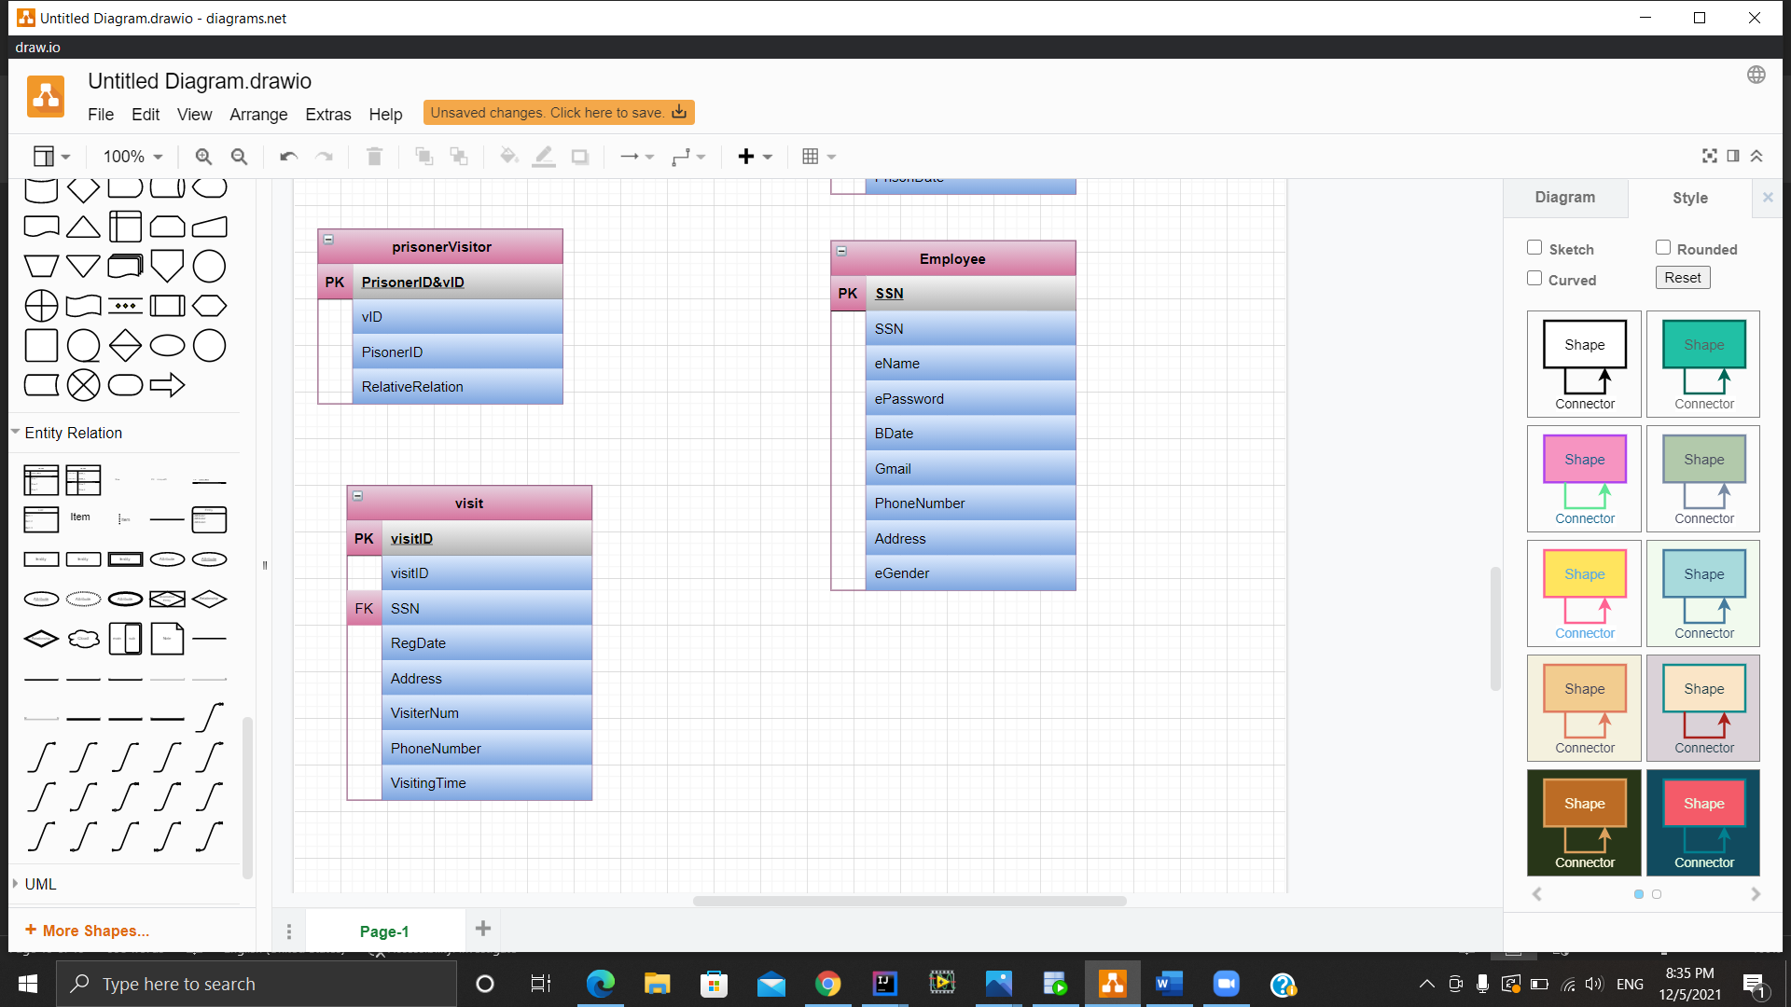

PrisonerVisitor vID,PrisonerID,RelativeRelation.

**visitPrisoner:**

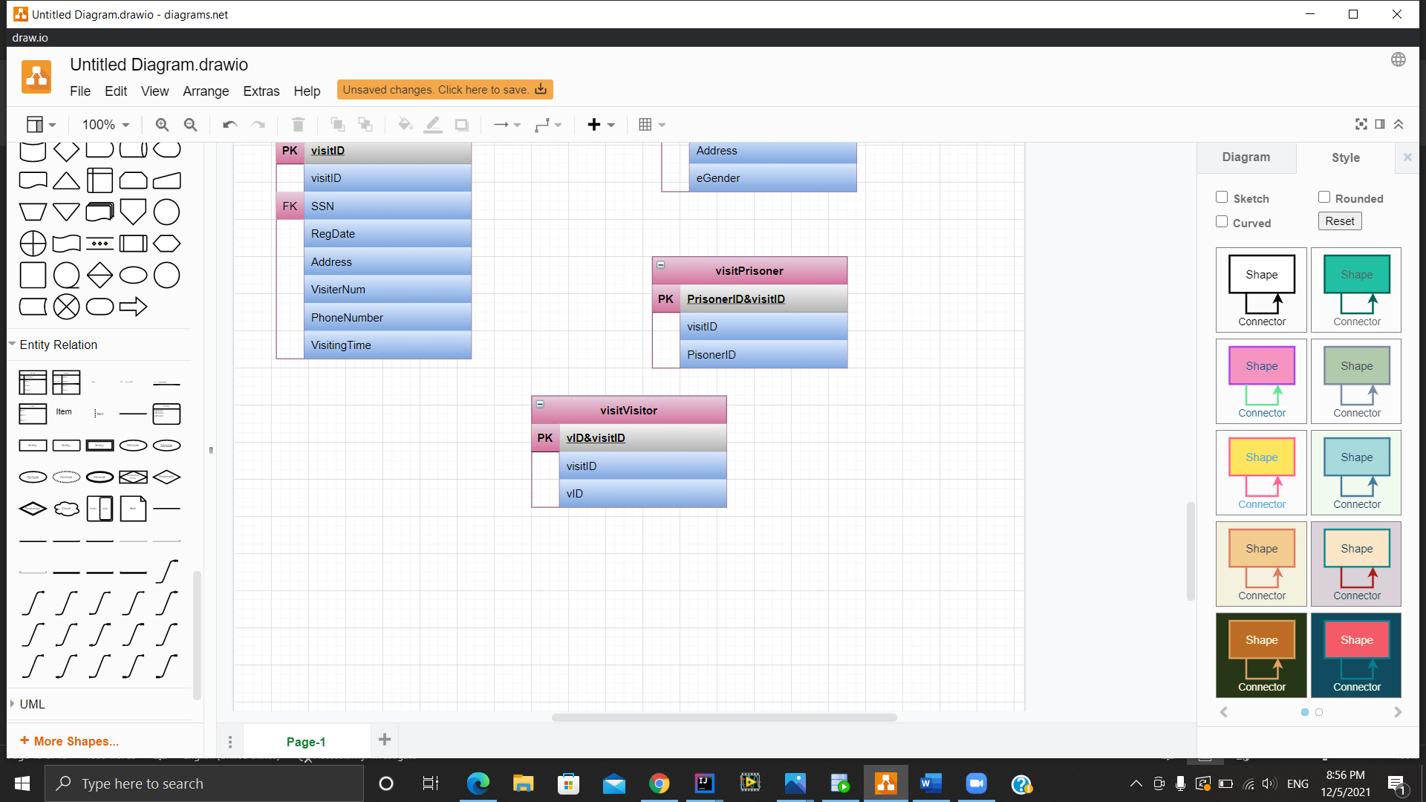

(VisitID,PrisonerID) VisitID, PrisonerID

**visitVisitor:**

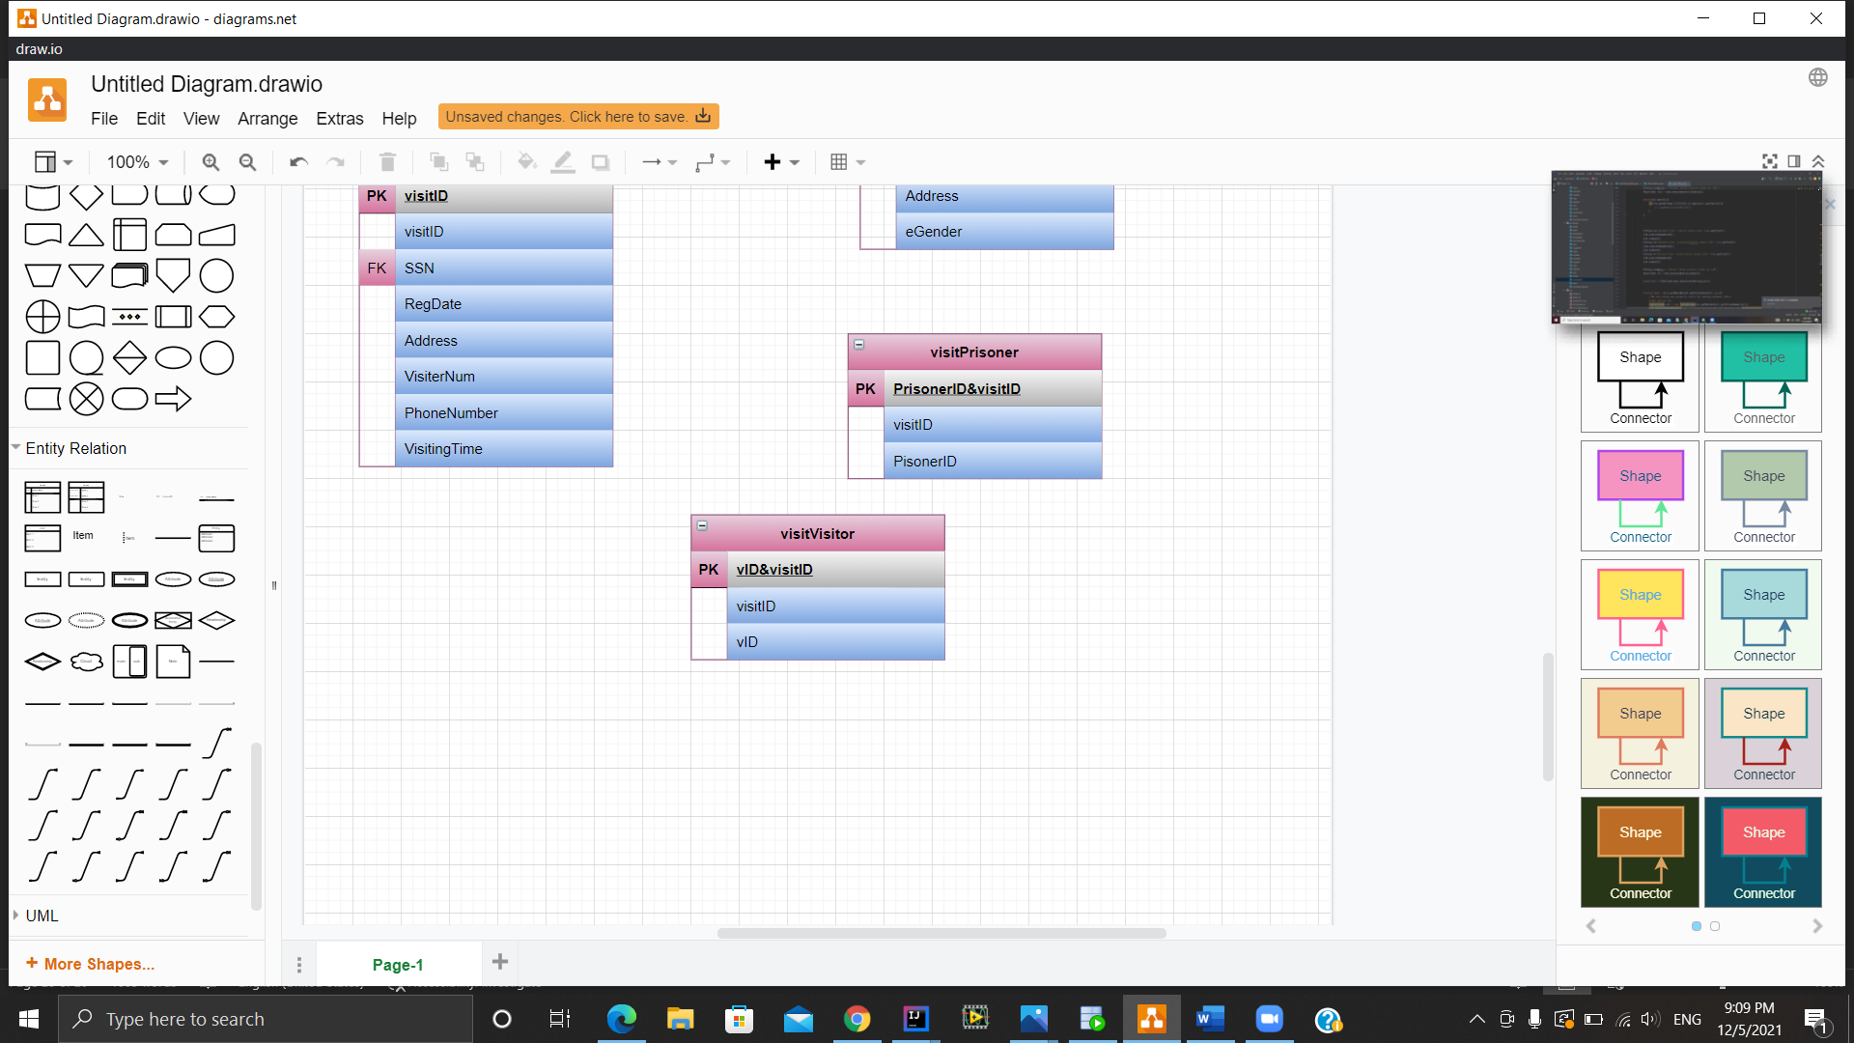

(VisitID,vID ) VisitID,vID.